Software Requirement Specification Document

For

<<Social Networking Platform>>

Table of Contents
Page Numbers
- Introduction
  - Purpose
  - Intended Customers/Users
  - Product Scope
  - Outline of the document
- Overall Description
  - Product Perspective
  - Product Functions
  - User Classes
  - Design and Implementation Constraints
- Diagrams
  - UML Diagrams
  - ER Diagrams
  - DFD Diagrams
  - Assumptions and Dependencies
- External Interface Requirements/Screenshots
  - User Interfaces
  - Hardware Interfaces
  - Software Interfaces
  - Communication Interfaces
- Other Non-Functional Requirements
  - Performance Requirements
  - Safety Requirements
  - Security Requirements
  - Software Quality Attributes
  - Business Policies/Rules (if any)
- Testing
  - Block-Box Testing
  - White-Box Testing
- Conclusion
- References
- Acknowledgements

- Introduction
1.1 Purpose
To provide a platform where people can collaborate, communicate, and connect with each other. Implementing feature of being anonymous to be open without fear of judgement.

1.2 Intended Users
Community members - Members of a closed community such as schools, company, universities etc.
Content creators- People who want to reach a specific audience with their posts

1.3Product Scope
The product will provide a platform for the users to interact with each other.
It will provide essential functionalities such as user authentication, messaging, profile management.
The system contains an additional feature of going “anonymous” which hides the user’s identity from other users and they can participate in discussions anonymously without revealing their identity, but it still can be seen by system administrators. This is to avoid:
Abuse
Violation of policies

Users can report someone even if they are anonymous and the report will be sent to the admins with reported content. If the content violates the policies the admins can give penalties to the reported user.

1.4 Outline of the Document
The Software Requirement Specifications (SRS) document is made to provide an organized description of the product. The Introduction section documents the purpose, intended user, product scope of the document.

2.Overall Description

2.1 Product Perspective
The software is a networking platform designed to function as a standalone application. The platform allows users to create profiles, connect with other users and networking features.
The system uses client-server architecture. The users interact with frontend and backend handles authentication, storage. It stores user’s profiles in a connected database.
Users use the system through a graphical user interface on devices. The backend services are hosted on cloud platform and the system requires internet for all core functionalities

2.2 Product Functions
- The system allows users to create, login and manage profiles.
- The system provides messaging functionalities between users.
-Users can interact anonymously.
- Administrator can manage users and regulate the rules for ensuring safety.

2.3 User Classes
General users- Individuals who want to interact with people can register their profiles, connect with others.
Access level - Interact with fellow users
Administrators- Individuals who regulate the rules of the application and lookout for any potential policy threat.
Access level- Can ban or suspend any user’s account

2.4 Design and Implementation Constraints
- The system must work on web browsers and mobile devices.
- The application requires internet connection for working.
- The backend must be hosted on cloud.

- Diagrams

3.1 UML Diagrams

- Use-case diagrams
1)Account Management
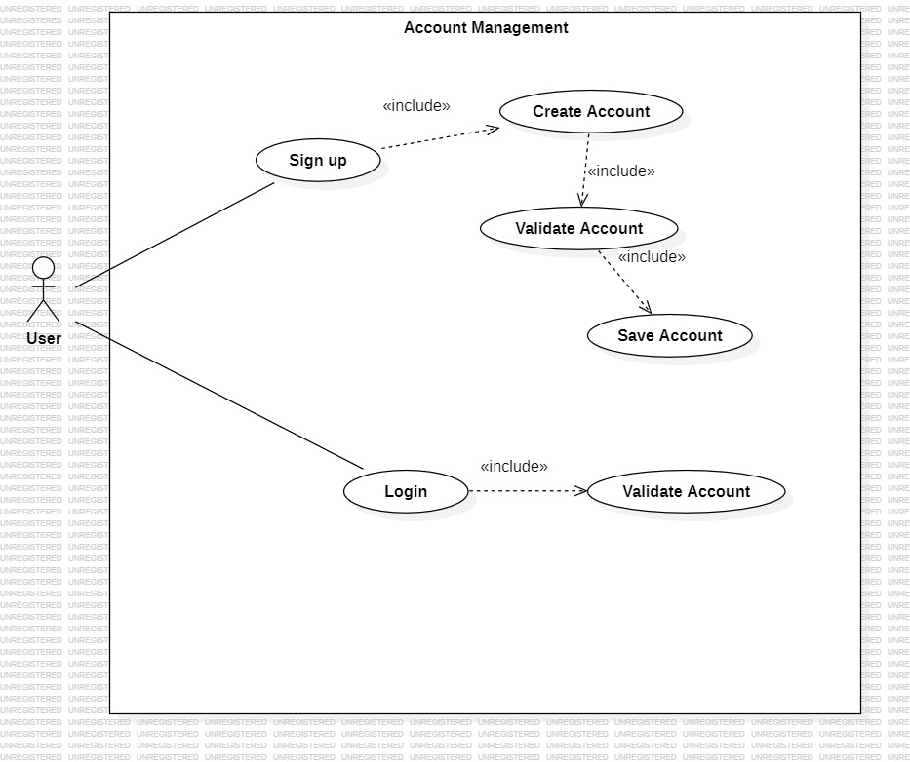
2)Profile Management
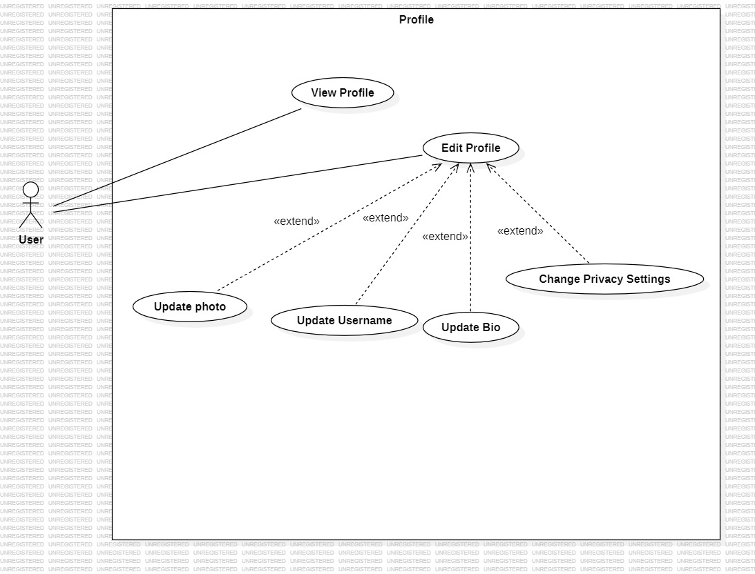

3)Friend Request
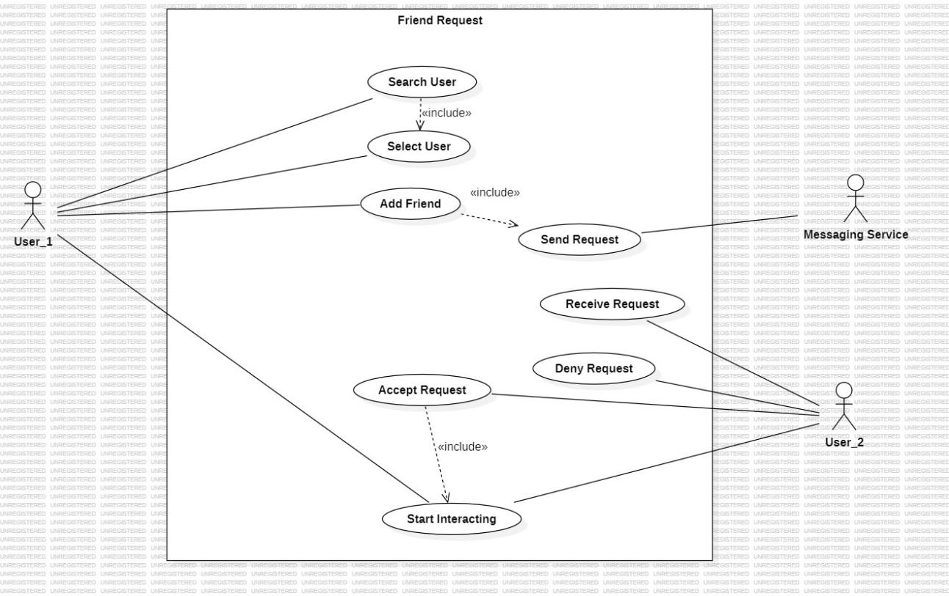

4)Anonymous Chat
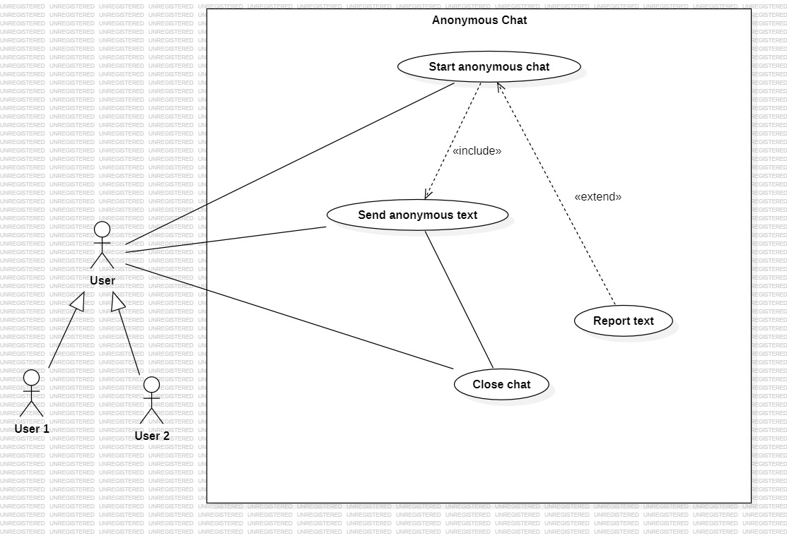

5)Administration
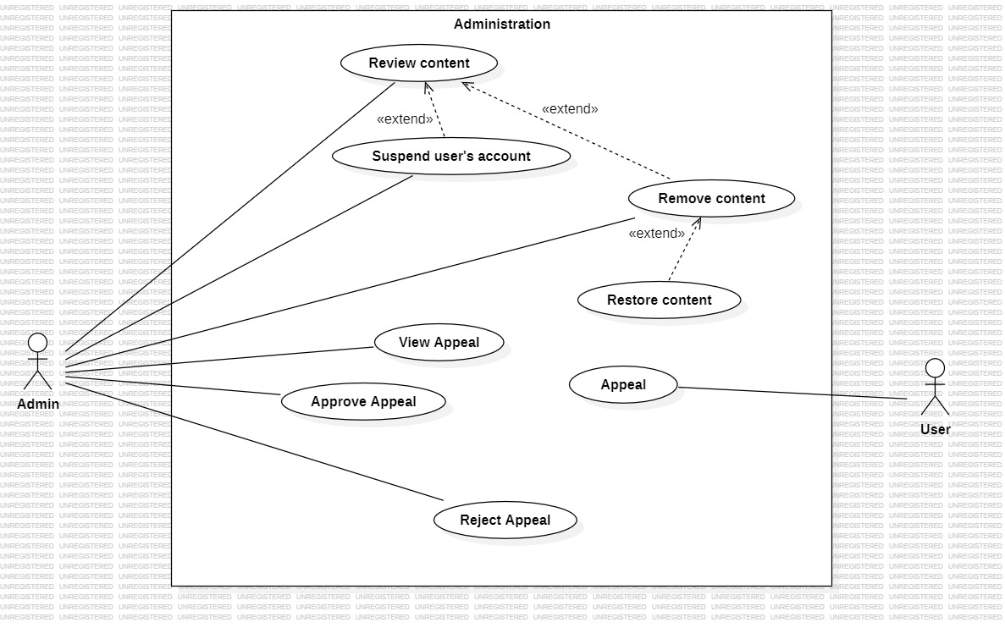

- ClassDiagrams
- Account Management
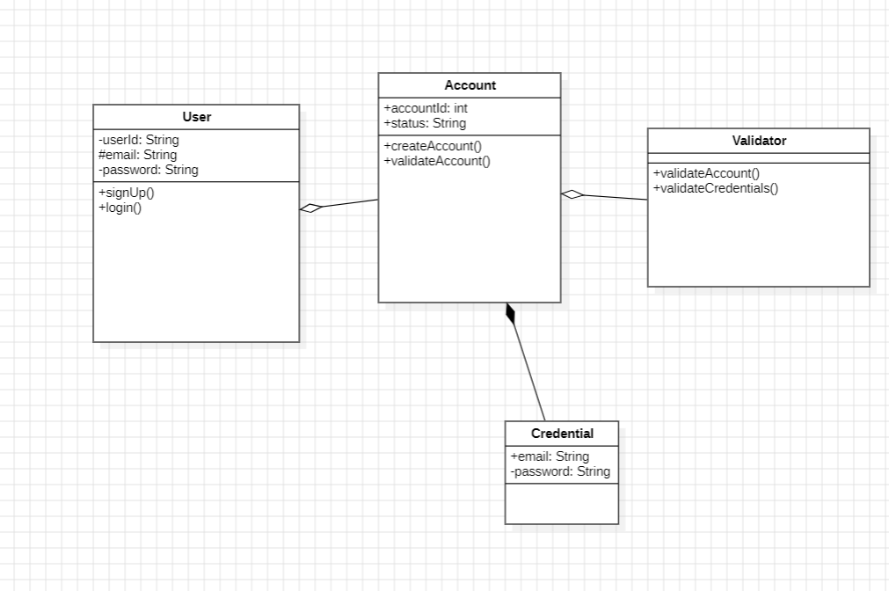
- Profile Management
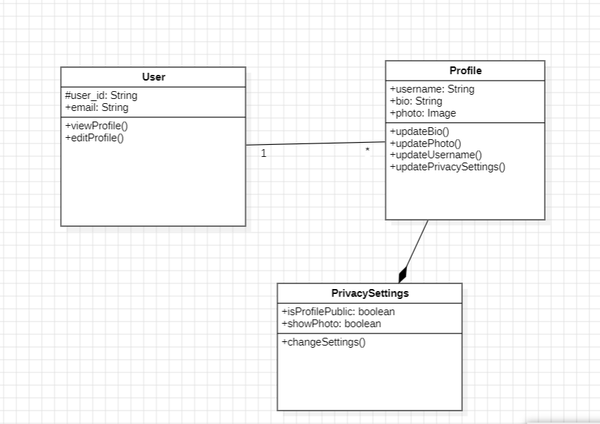
- Friend request
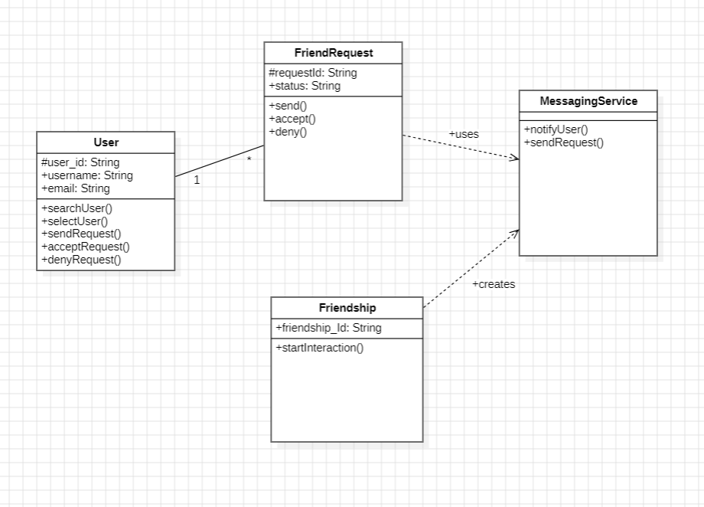
- Anonymous Chat
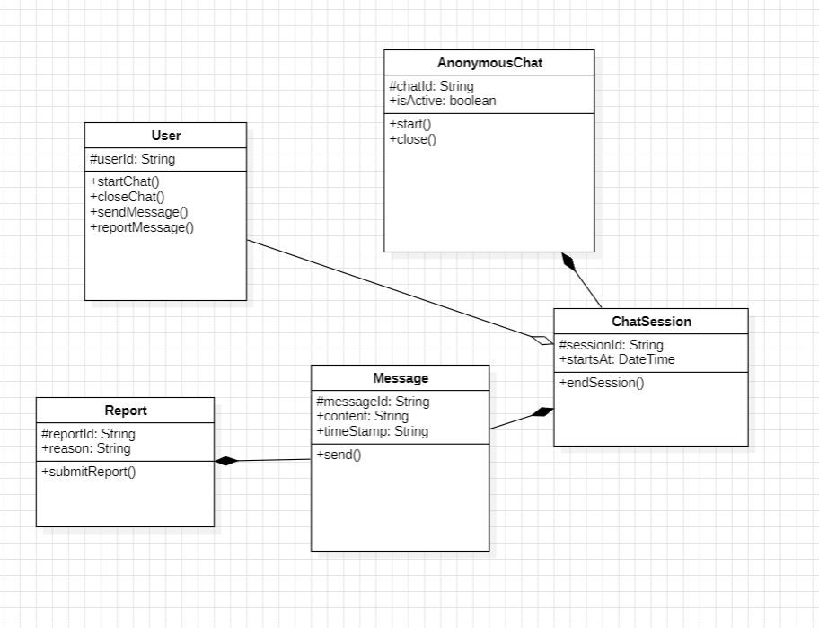
- Administration
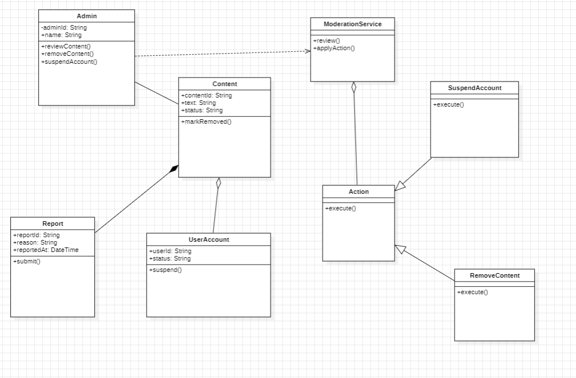

Sequence Diagrams
- Account Management
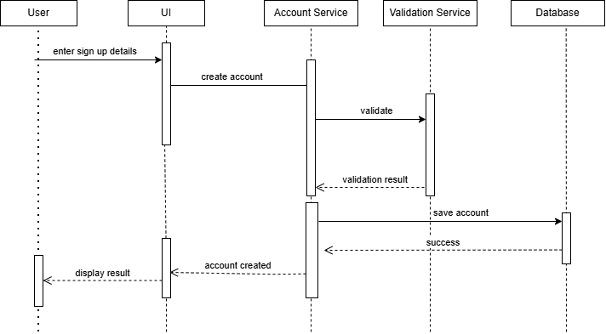

Collaboration Diagrams
- Account Management
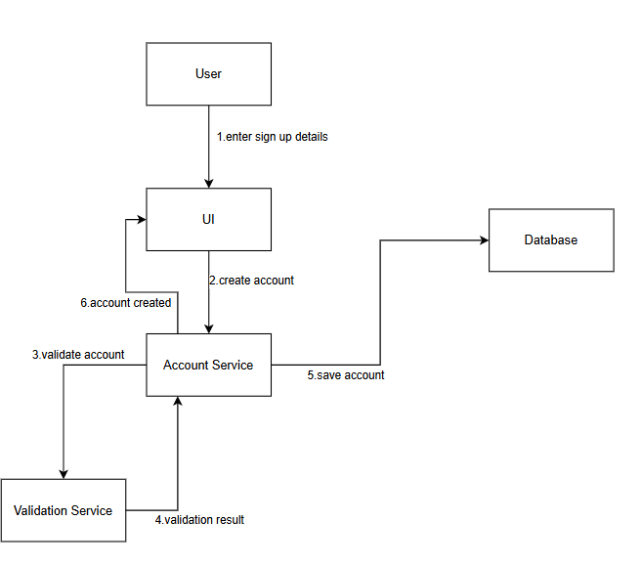

ER Diagram
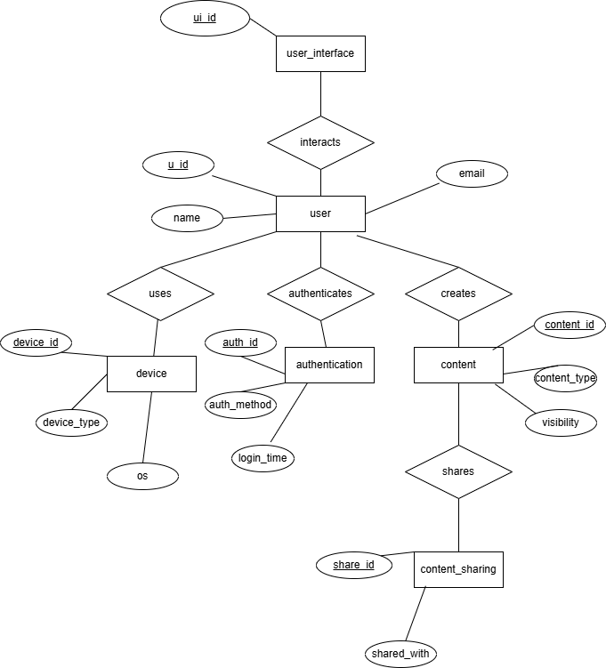

Data Flow Diagram
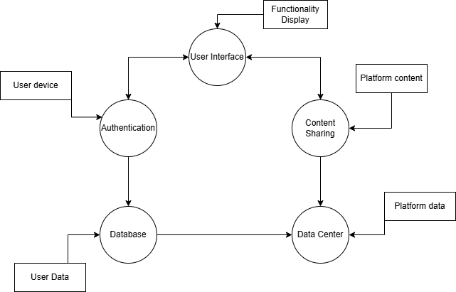

4.External Interface Requirements
4.1 User Interfaces
The platform will provide a simple user-friendly user interface which can be accessed through web browser and mobile devices.
UI Components-
-Login and Registration page
-Profile management screen
-Content creation interface
-Messaging interface
-Notification section

4.2 Hardware Interfaces
Client Side Hardware
-Smartphones
-Tablets
-Laptops
-Desktop Computers
-Camera(for photo,video)
-Microphone(for voice features)
Server Side Hardware
-Data Centers
-Storage System
-Backup Servers
4.3 Software Interfaces
The platform will support multiple services and software components.
Operating Systems supported-
-Windows
-Android
-iOS

External Software/Services
-Web browser
-Database Management System
-Authentication Services
-Cloud Storage Services
-Backend APIs

4.4 Communication Interfaces
The platform will communicate between users and various software components
Network Communication-
-Internet
-HTTP Protocols
-Web Sockets
Data Communication-
-REST API
-Authentication Tokens

Security Communication-
-SSL/TSL Encryption
-Data privacy communication

- Other Non-Functional Requirements
5.1 Performance Requirements
The platform must provide fast and efficient performance across different systems.
-System should support thousands of users at the same time
-Page load time should be less than 3 seconds
-Chat and notification features should have minimum delay
-System should be able to handle traffic spikes
5.2 Safety Requirements
The system must ensure protection of user data and prevent accidental data loss
-System should have backup recovery mechanism.
-Data must not be lost due to system crash.
-Content moderation should prevent harmful and illegal content.
-Regular data backup system should me present.
5.3 Security Requirements
-All communication must be encrypted
-Passwords must be stored using hashing algorithms.
-System must include authentication and authorization.
-Protection against common attacks on system.
-Implementation of user privacy settings.
5.4 Software Quality Attributes
Reliability- System should run continuously and reliably.
Scalability- System should be able to handle increasing users and new system support.
Maintainability- The system should be maintained such as servers.
5.5 Business Policies/Rules
-User must follow community guidelines
-Age restrictions must be applied
-Spam, fake accounts will result in account suspension.
-Platform must comply with data protection and privacy policies

- Testing
Unit -1
//connect for client
public void connect() throws UnknownHostException, IOException {
new Thread(new Runnable() {

@Override
public void run() {
Socket socket;
try {
socket = new Socket("localhost", 8888);
InputStreamReader inputStreamReader = new InputStreamReader(socket.getInputStream());
br = new BufferedReader(inputStreamReader);

OutputStreamWriter outputStreamWriter = new OutputStreamWriter(socket.getOutputStream());
bw = new BufferedWriter(outputStreamWriter);

receive();

} catch (UnknownHostException e) {
System.out.println("Connection could not be established...");
} catch (IOException e) {
e.printStackTrace();
}
}
}).start();
}

Black Box Testing -
Test Case ID | Input | Expected Output | Actual Output | Result
TC1 | Server running on localhost | Client connects and receive() starts | Connection established | Pass
TC2 | Server not running on locahost | Connection fails and message “Connection failed” printed | Message printed | Pass
TC3 | Invalid host address | UnknownhostException handled and connection fails | Error message shown | Pass
TC4 | Network Interrruption during connection | IOException handled and stack trace printed | Exception Printed | Pass

White Box testing-
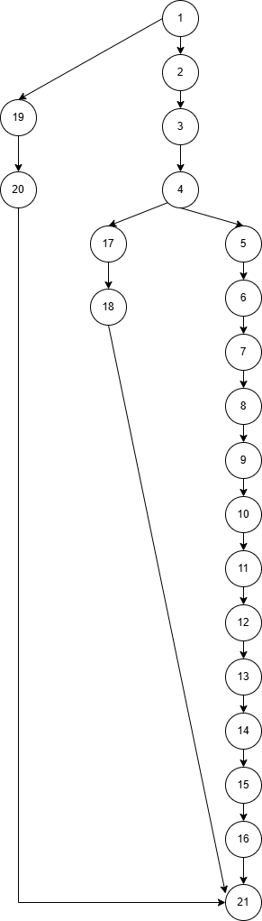
Cyclomatic complexity = decision points + 1
= 2 + 1
=3

Independent Program Paths-
Path 1= 1-19-20-21
Path 2= 1-2-3-4-17-18-21
Path 3 = 1-2-3-4-5-6-7-8-9-10-11-12-13-14-15-16-21

Unit -2
//connect for server
public void connect() throws IOException {
ServerSocket serverSocket = new ServerSocket(8888);
System.out.println("Server started...");
List<Socket> clients = new ArrayList<>();
new Thread(new Runnable() {
@Override
public void run() {
while(true) {
try {
Socket socket = serverSocket.accept();

System.out.println("A client connected");

clients.add(socket);
new Thread(new Runnable() {

@Override
public void run() {
try {
InputStreamReader in = new InputStreamReader(socket.getInputStream());
BufferedReader br = new BufferedReader(in);
String username = br.readLine();
Platform.runLater(new Runnable(){

@Override
public void run() {
lv.getItems().add(username);
}
});
String text;
while((text = br.readLine())!= null) {
String msg = text;
broadcast(clients,socket, msg);
Platform.runLater(new Runnable() {

@Override
public void run() {

textArea.appendText(username + ": "+ msg + "\n");
}

});
}

} catch (IOException e) {
e.printStackTrace();
}

}

}).start();
} catch (IOException e) {
e.printStackTrace();
}
}
}

}).start();
}

Black Box Testing-
Test Case ID | Input | Expected Output | Actual Output | Result
TC1 | Server started | Server prints “Server started…” and waits for clients | Message printed | Pass
TC2 | Client connects to server | Server prints “A client connected” | Message printed | Pass
TC3 | Client sends username | Username added in the ListView | Username added | Pass
TC4 | Client sends a message | Message broadcasted to other clients | Message received by other clients | Pass
TC5 | Client disconnects | while((text = br.readLine())!= null) ends without crashing | Program does not crash | Pass

White Box Testing-
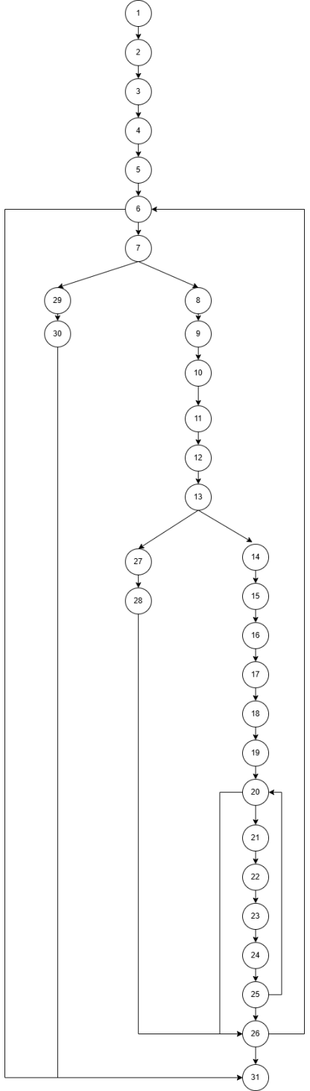
Cyclomatic Complexity = decision points + 1
= 4 + 1 = 5

Independent Program Paths-
Path 1 = 1-2-3-4-5-6-7-29-30-31
Path 2 = 1-2-3-4-5-6-7-8-9-10-11-12-13-27-28-26-back to 6
Path 3 = 1-2-3-4-5-6-7-8-9-10-11-12-13-14-15-16-17-18-19-20-21-22-23-24-25-26-back to 6
Path 4 = 1-2-3-4-5-6-31
Path 5 = 1-2-3-4-5-6-7-8-9-10-11-12-13-14-15-16-17-18-19-20-26-31

Component Level Diagram
Friend Request
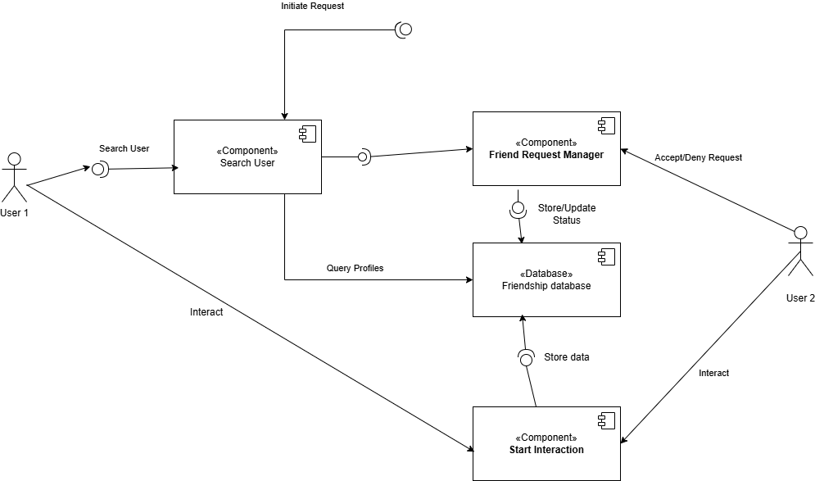

Deployment Level Diagram
Friend Request
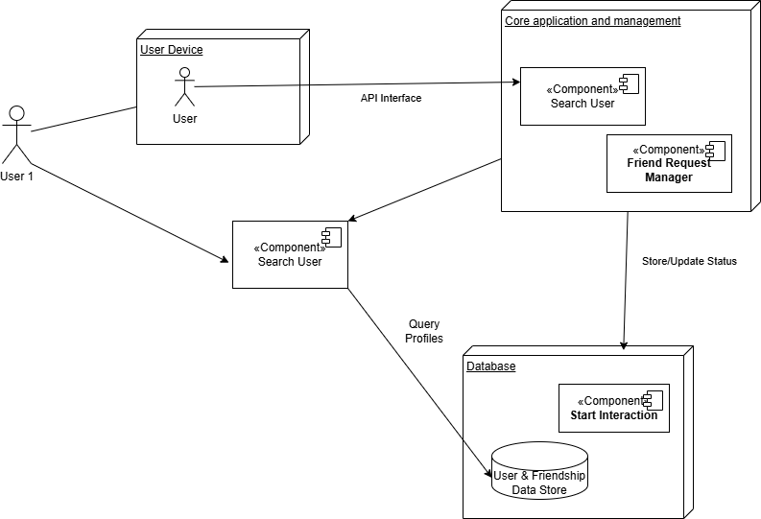
FPA (Functional Point Analysis)

Component Type | Count | Weight | Total
External Inputs | 6 | 4 | 24
External Outputs | 5 | 5 | 25
External Inquiries | 4 | 4 | 16
Internal Logical Files | 3 | 10 | 30
External Interface Files | 2 | 7 | 14

Unadjusted Function Point
UFP = 24 + 25 + 16 + 30 + 14 = 109
Value Adjustment Factor
VAF = 0.65 + (0.01 * 40) = 1.05
Final Function Point
FP = UFP * VAF = 109*1.05 = 114.45

If 1FP = 20 hours then 114.45 * 20 = 2289 hours
If developer cost = Rs 1000 per hour,
Then total cost = 1000 x 2289 = Rs 2289000

COCOMO MODEL
The project is classified under the Semi-Detached mode as it involves moderate complexity, multiple modules such as user profiles, posts, messaging, and database management, and requires a team with mixed levels of experience.
The estimated size of the project is 25 KLOC.

Effort :
3.0 x (KLOC)^1.12 = 3.0 x (25)^1.12
=110 person-months
Development Time:
2.5 x (Effort)^0.35 = 2.5 x (110)^0.35
= 13 months
People Required:
Effort / Time = 110/13 = 8-9 members

